**1)What is software? What is software engineering? :**

software is a set of programs (sequence of instructions) that allows the users to perform a well-defined function or some specified task.*"*

**Software** is a collection of codes, documents, and triggers that does a specific job and fills a specific requirement.  
  
**Engineering** is the development of products using best practices, principles, and methods.

**2)Explain types of software :**

3 types of software:

**System software:**

System software**is a computer program that helps the user to run computer hardware or software and manages the interaction between them**. Essentially, it is software that**constantly runs in the computer background, maintaining the computer hardware and computer's basic functionalities, including the operating system, utility software, and interface.**

**Utility software:**

**Utility software is developed to provide support in analyzing, optimizing, along configuring and maintaining a computer.**

**Application software:**

**Application programs or software applications are end-user computer programs developed primarily to provide specific functionality to the user.**The applications programs assist the user in accomplishing numerous tasks such as doing**online research, completing notes, designing graphics, managing the finances, watching a movie, writing documents, playing games, and many more.**

**3)What is SDLC? Explain each phase of SDLC:**

SDLC means software development life cycle,The software development life cycle refers to a methodology, with clearly defined processor for creating high-quality software.

***Phase of SDLC***:

*Planning:

The planning stage (also called the feasibility stage) is exactly what it sounds like: the phase in which developers will plan for the upcoming project.  
*Analysis:

The analysis stage includes gathering all the specific details required for a new system as well as determining the first ideas for prototypes.

Developers may:

* Define any prototype system requirements
* Evaluate alternatives to existing prototypes
* Perform research and analysis to determine the needs of end-users

*Designing:

In this phase, the software design is created, which includes the overall architecture of the software, data structures, and interfaces. It has two steps:

**High-level design (HLD):** It gives the architecture of software products.

**Low-level design (LLD):** It describes how each and every feature in the product should work and every component.

*Implementation:

Implementation/Coding starts once the developer gets the Design document. The Software design is translated into source code. All the components of the software are implemented in this phase.

*Testing:

The software is thoroughly tested to ensure that it meets the requirements and works correctly.

*Maintaince:

After the deployment of a product on the production environment, maintenance of the product

**i.e.** if any issue comes up and needs to be fixed or any enhancement is to be done is taken care by the developers.

**4)What is DFD? Create a DFD diagram on Flipkart:**

Data flow diagram (DFD) is **a diagram being used frequently in software design**.

It visually represents the flow of data throughout processes in a given system. DFD shows the kind of information that will be input to and output from processes as well as where the data will be stored.

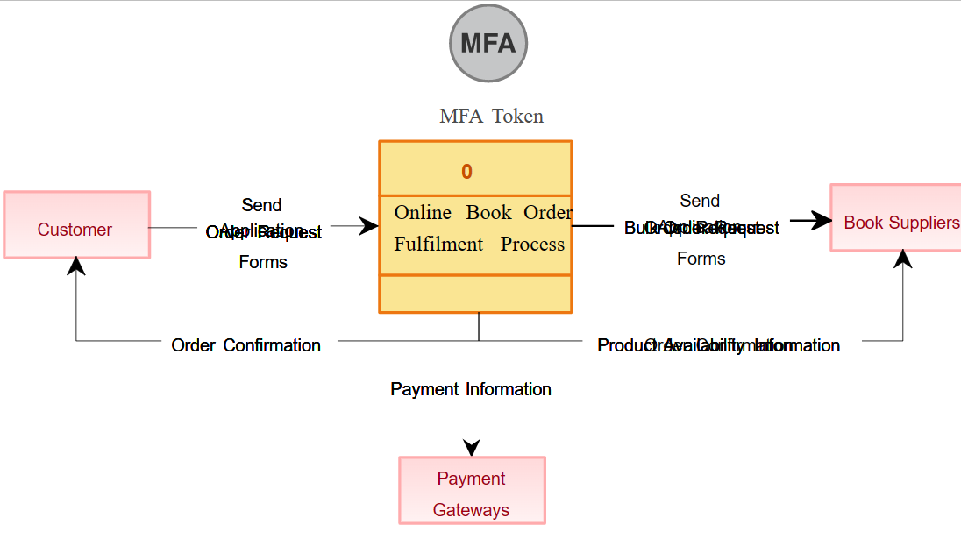

**5)What is Flow chart? Create a flowchart to make addition of two numbers :**

A **flowchart** is a type of [diagram](https://en.wikipedia.org/wiki/Diagram) that represents a [workflow](https://en.wikipedia.org/wiki/Workflow) or [process](https://en.wikipedia.org/wiki/Process). A flowchart can also be defined as a diagrammatic representation of an [algorithm](https://en.wikipedia.org/wiki/Algorithm), a step-by-step approach to solving a task. The flowchart shows the steps as boxes of various kinds, and their order by connecting the boxes with arrows.

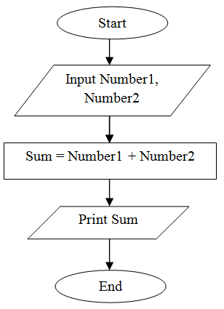

**6)What is Use case Diagram? Create a use-case on bill payment on paytm. :**

Use-case diagrams describe the high-level functions and scope of a system. These diagrams also identify the interactions between the system and its actors. The use cases and actors in use-case diagrams describe what the system does and how the actors use it, but not how the system operates internally.

